Jennifer Stegina

20 September 2019

CIS 250

**Unit 4 Guided Practice 4**

The following questions come from the Task examples in Chapter 14 in your textbook.

After you are finished, please submit a Microsoft Word file that contains screenshots of the SQL queries, the output, and a comment in the query file with your name. Your document should be named **U4_GuidedPractice4_Lastname.docx**.

(14-8) Question 1:

Show the number of lunches each employee will attend. Include all the employees. Show a zero if the employee is not attending any lunches.

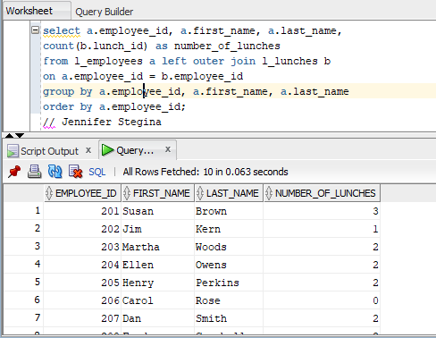

(14-9) Question 2:

Create an outer join of the *l_employees* table and the *l_lunches* table. Retain all the rows of data from both tables.

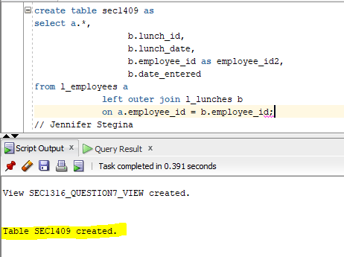

(14-9) Question 3:

Show the number of lunches each employee will attend. Start with the *sec1409* table. Then select these columns: *employee_id, first_name,* and *last_name*. Group these data and summarize them to count the number of lunches each employee will attend.

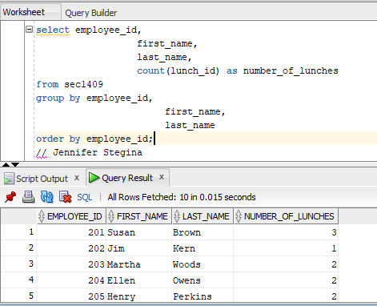

(14-10) Question 4:

Create a full outer join of the twos table and the threes table. Create a column that will sort the rows in numeric order.

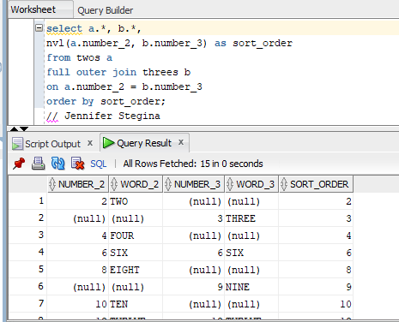

(14-11) Question 5:

The table *sec1411_numbers* contains the numbers from 1 to 1,000. A few numbers are missing and a few numbers are repeated. Find all the missing numbers and all the repeated numbers. Count the number of times each of these numbers occurs. For the missing numbers, count that they occur zero times.

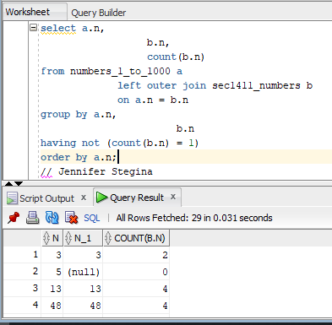

(14-12) Question 6:

Find the rows in the *sec1412a* table that do not exist in the *sec1412b* table.

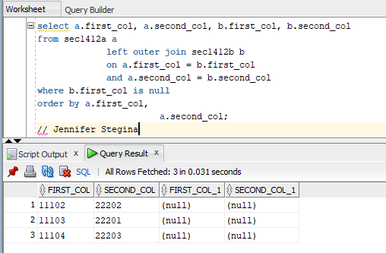

(14-13) Question 7:

Use the two tables *sec1413_fruits* and *sec1413_colors*. Form the full outer join of these tables using the join condition:

*f_num = c_num*

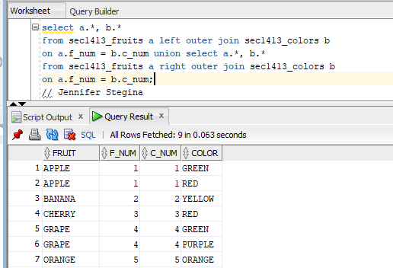

Then form the full outer join using the join condition:

*fruit = color*

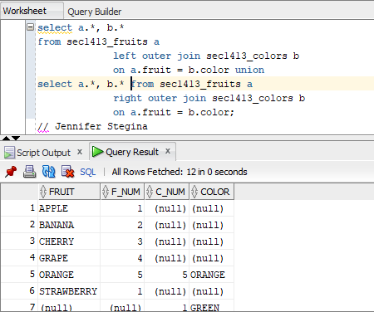

Examine the result tables. State what is similar and what is different about these full outer joins.

The similarities are that they both contain all the rows from the beginning tables and all the columns from the beginning tables.

The differences are that the first full outer join had 9 total rows, 6 rows in the results table that matched a fruit and a color, 3 rows in the result table that had an unmatched fruit or color, 4 fruits from the beginning table that matched with at least one color, 2 fruits from the beginning table that did not match with any color, 4 colors from the beginning table that matched with at least one fruit, and 1 color from the beginning table that did not match with any fruit. The second full outer join had different results in every row listed above.